Letter of Authorization

To whom it may concern

I understand that Moolya Software Testing Pvt Ltd may use an external/internal agency/function to verify and validate the information I have provided including my employment, my personal background, professional standing, work history and qualifications.

I understand that an external/internal agency/function may obtain information it deems appropriate from various sources including, but not limited to, the following: current and past employers, criminal conviction records, school records, college records and professional and personal references.

I authorize, without reservation, any individual, corporation or private or public entity from any or all causes of action that might arise from furnishing to Moolya Software Testing Pvt Ltd and the external/internal agency/function information that they may request pursuant to this release.

This authorization and release, in original, faxed or photocopied form, shall be valid for this and any future reports and updates that may be requested.

Signed:

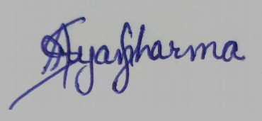

Name in block capitals: ARYAN SHARMA

Date of birth: 23 NOV 1999

Date: 23 JAN 2022